How to turn on or turn off WiFi button?
Step 1: Open the browser and input plc.tendawifi.com in address bar to login setup page. By default, password is “admin”.
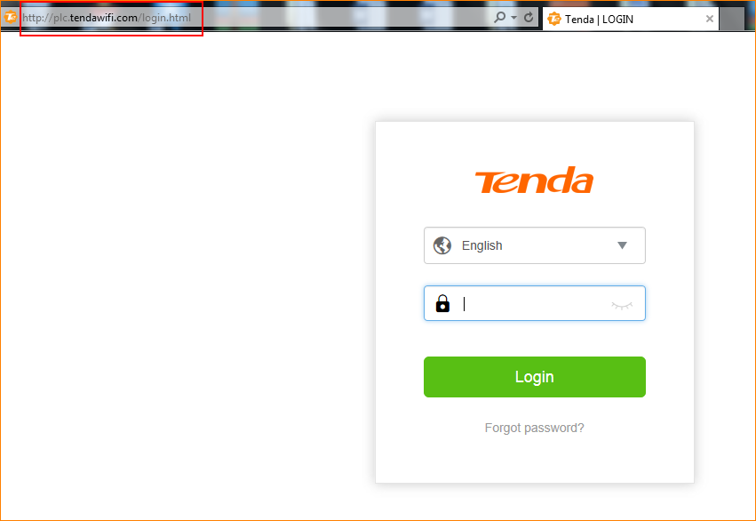
Step 2: Choose “WiFi”, tap 2.4G button or 5G button to turn off WiFi. Tap “OK” to save the settings.

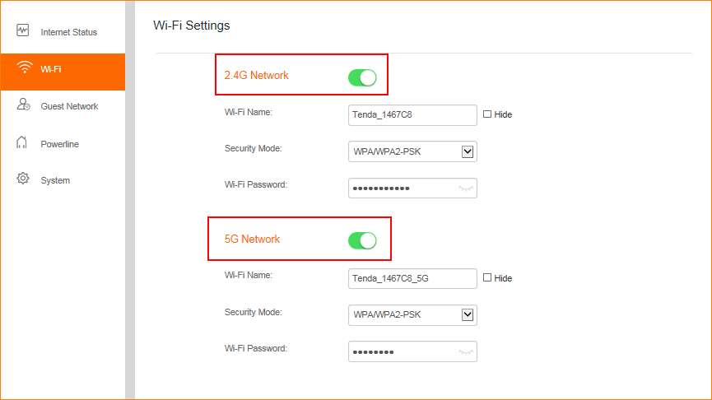
Note: By default, 2.4G and 5G band are on with SSID and password.

